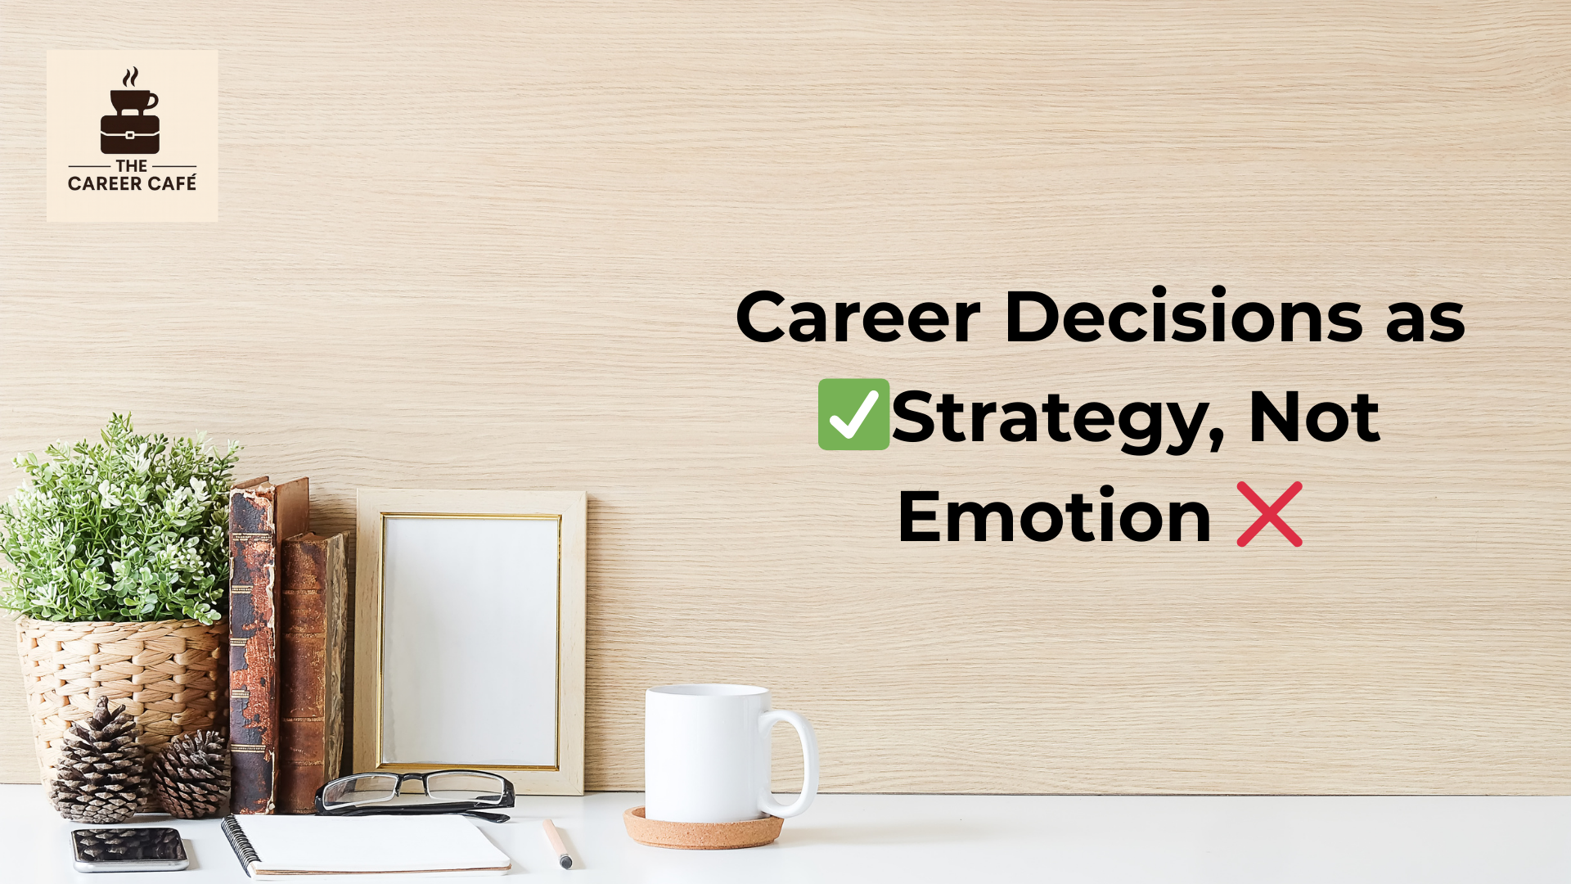

Career Decisions as Strategy, Not Emotion
Have you ever felt the pressure to earn more, to leave a difficult manager, to keep up with peers, or simply to respond quickly to uncertainty? Pressure is all around us, and more often than not, it is driven by emotion.
In those moments, emotion feels like action. It creates urgency. It pushes us toward movement. But emotion is rarely a strategy.
January, in particular, amplifies this dynamic. It is framed as a season of bold resolutions and decisive career moves - new roles, new industries, new identities. While reflection is healthy, many career decisions made during this period are reactions to fatigue, frustration, or comparison rather than outcomes of clear, strategic thinking.
Let’s pause and talk about this. More importantly, let’s examine the long-term cost of emotionally driven career decisions - and what it means to approach careers with strategy instead.

The Hidden Cost of Emotion-Led Career Moves
Emotion is not the problem. Emotion is information. It signals dissatisfaction, misalignment, or unmet expectations. The risk emerges when emotion becomes the primary decision-maker.
Professionals often respond to discomfort by changing environments rather than interrogating the root cause of the discomfort itself. A role feels limiting, so they resign. A manager is difficult, so they exit. Compensation feels insufficient, so they chase the next offer. Yet months later, similar frustrations resurface in a different organization.
This happens because emotional decisions tend to focus on escape rather than design.
A career move made to relieve pressure may reduce short-term stress, but if it does not address capability gaps, unclear positioning, or structural constraints, it simply relocates the problem. Over time, repeated reactive moves can fragment a professional profile, dilute expertise, and weaken long-term credibility.
The cost is not just instability. It is lost compounding.

How to Shift from Feelings to Frameworks
Moving from emotional to strategic decision-making does not require perfection. It requires structure.
Before making a major career move, it helps to pause and assess four critical dimensions. ACET
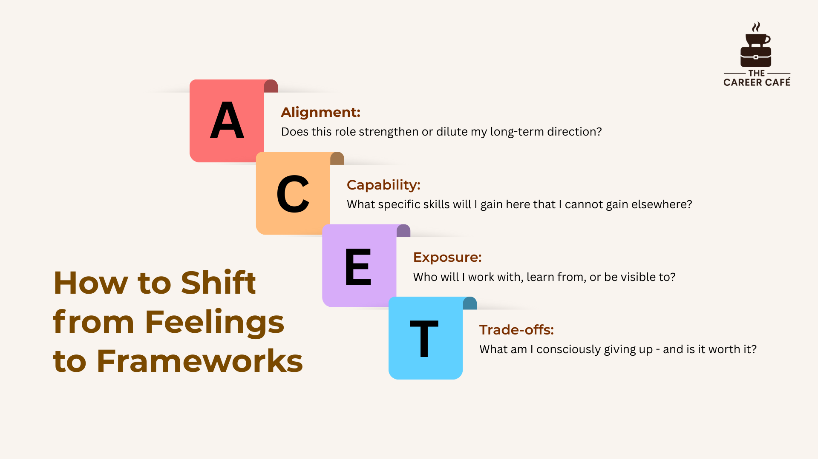
This framework does not remove emotion. It disciplines it. Emotion becomes an input - not the driver.

Strategy Starts with Positioning, Not Passion
Much mainstream career advice begins with passion. While passion matters, it is not a strategy. Strategy begins with positioning - how your skills, experience, and credibility intersect with real demand.
Professionals who make strategic decisions understand where they sit within the value chain of their industry. They know what problems they solve, for whom, and at what level of complexity. This clarity allows them to move intentionally rather than impulsively.
Consider a communications professional who feels unfulfilled in a corporate role and is tempted to abandon the sector entirely in search of “more meaningful work.” A strategic lens might reveal alternative pathways: internal change communication, public-sector engagement, ESG reporting, or stakeholder relations. These options deepen impact while preserving and strengthening accumulated expertise.
Strategy often looks less dramatic than emotion. But over time, it is far more effective.

Careers Exist Within Systems
Careers do not exist in isolation. They operate within systems, organizational structures, labour markets, education pipelines, economic realities, and access to opportunity. Strategic career thinkers account for these systems when making decisions.
This is especially important in times of uncertainty. Roles evolve. Skills become obsolete. Industries shift. Professionals who rely solely on confidence in their current position may find themselves exposed when conditions change.
Strategic thinking asks different questions:
- How portable are my skills?
- How exposed is my role to automation or restructuring?
- What signals does my experience send beyond my current organization?
This is why forward-looking professionals invest in learning before they are forced to. They track demand, build relevance, and strengthen optionality while still stable. Emotion waits for disruption. Strategy anticipates it.

What Strategic Decision-Making Looks Like in Practice
Strategic career decisions are rarely impulsive, and they are seldom rushed.
Take the example of a mid-career finance professional experiencing disengagement. Emotion suggests an immediate exit or a radical industry switch. Strategy suggests a pause. A structured review reveals strong transferable skills - risk analysis, regulatory knowledge, stakeholder reporting - that are in demand across multiple sectors.
Instead of resigning immediately, the professional pursues targeted learning, seeks cross-functional exposure, and tests adjacent roles through short-term projects. The eventual transition is not a reaction to burnout, but a deliberate step that builds on existing capital while opening new pathways.
The difference is not bravery. It is clarity.

This Matters Beyond the Individual
Strategic career thinking is not only an individual responsibility. Institutions and employers have a role to play.
Organizations that support structured career development benefit from stronger retention, clearer succession planning, and more engaged teams. When professionals understand how their roles connect to long-term growth, they are less likely to disengage or exit prematurely.
Conversely, environments that rely on pressure, urgency, or vague promises of “growth” often experience high turnover - not because people lack commitment, but because they lack clarity.
Career clarity is a systems issue. It affects productivity, talent sustainability, and institutional resilience.

Reframing January Career Decisions

January does not need to be a season of reactive exits or rushed reinvention. It can be a season of alignment.
Before making any major career move, it is worth asking: Am I reacting, or am I designing? Does this decision increase my long-term options? What problem am I actually trying to solve?
At The Career Café, we believe sustainable careers are built through informed, structured decisions - not emotional swings. Strategy does not eliminate uncertainty, but it significantly reduces regret.
As the year begins, the most powerful career decision may not be what you change, but how you choose to decide.

CAPTION

Have you ever felt the pressure to earn more, leave a difficult manager, keep up with peers, or respond quickly to uncertainty - and wondered what action you should take?
Many people who have been in those positions admit that they acted out of emotion. They moved fast. They exited quickly. They chose relief over clarity.
In this article, we unpack why emotionally driven career decisions often come at a long-term cost - and how shifting from feelings to frameworks helps professionals make clearer, more strategic choices.
Read the full article and share any emotions you have seen lead to rushed career decisions in yourself or others

